Software Engineering Project

Group 3

**User manual**



Team Members:

**120101002** ABHINAV MITTAL

**120101003**  ABHINAV RAVI

**120101004**  ABHISHEK GOYAL

**120101032**  KAZIPETA SHARATH

**120101036**  KONAKANCHI REVANTH GOPI

**120101041**  MOHIT

**120101045**  NISHANT GUPTA

**120101057**  RANU VIKRAM

**120101058**  RAVINDRA SINGH GURJAR

**120101061**  ROHITASHVA KUMAR MEENA

**120101062**  ROSHAN NATHANI

**120101066**  SANDEEP SAMATAM

**120101083** ABHIJEET SINGH

­­**120101087** ABHISHEK SEN

**Preface**

The document herein was produced by the **Saanji Drive Team**, a group of highly enthusiast computer science undergraduates of the Indian Institute of Technology Guwahati. This document is intended to provide user manual of this project, Saanji Drive, a web-based file sharing portal with the provision of auto-synchronization of files as the user is on the move.

The Saanji Drive Team

2nd Year,

Department of Computer Science and Technology,

Indian Institute of Technology Guwahati

Guwahati – 781039,

India

1. **Web Application**

This is an introduction to the Project on Web-Based-File-Hosting-Server. This Project has been developed to construct an online drive storage developed with these functionalities

* Login

-- Sign in

-- Sign out

-- Sign up

-- Forgot password

* Manage Folders

-- Add folder

-- Remove folder

-- Move folder

-- Rename folder

* Upload file
* Download file
* Search
* Share file
* Preview file
* Edit file

**LOGIN PAGE:**

When user host to the web application then the first login form will be like this

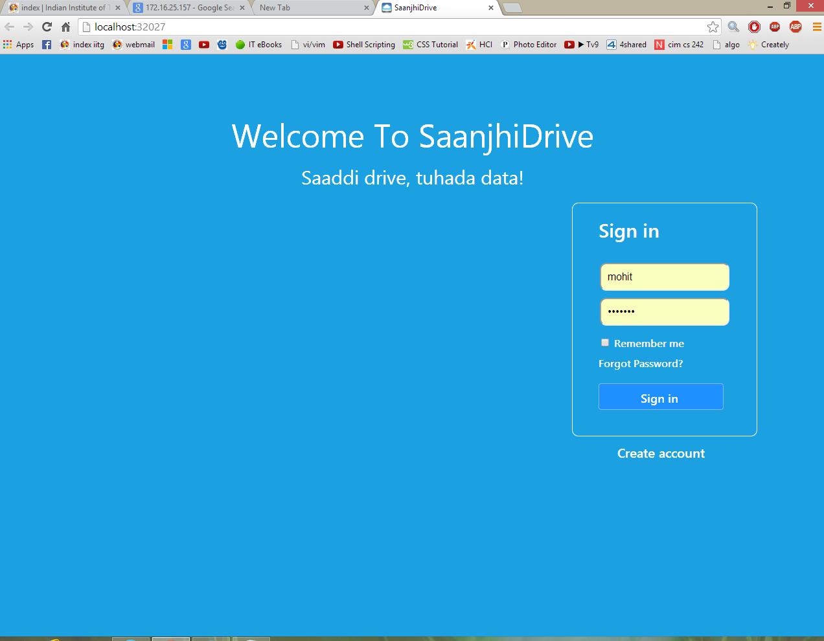

Then they will find the Login form then they can using there username and password they can login.

If the user forgot there password they can use forgot password then one window will be popup like this

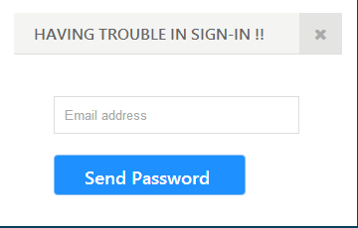

If they are new user they can create a new account by clicking on **Create account** then one window will be popup like this

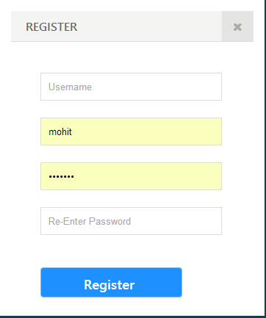

**HOME PAGE:**

Once the user is logged in successful then the home page will be popup like this

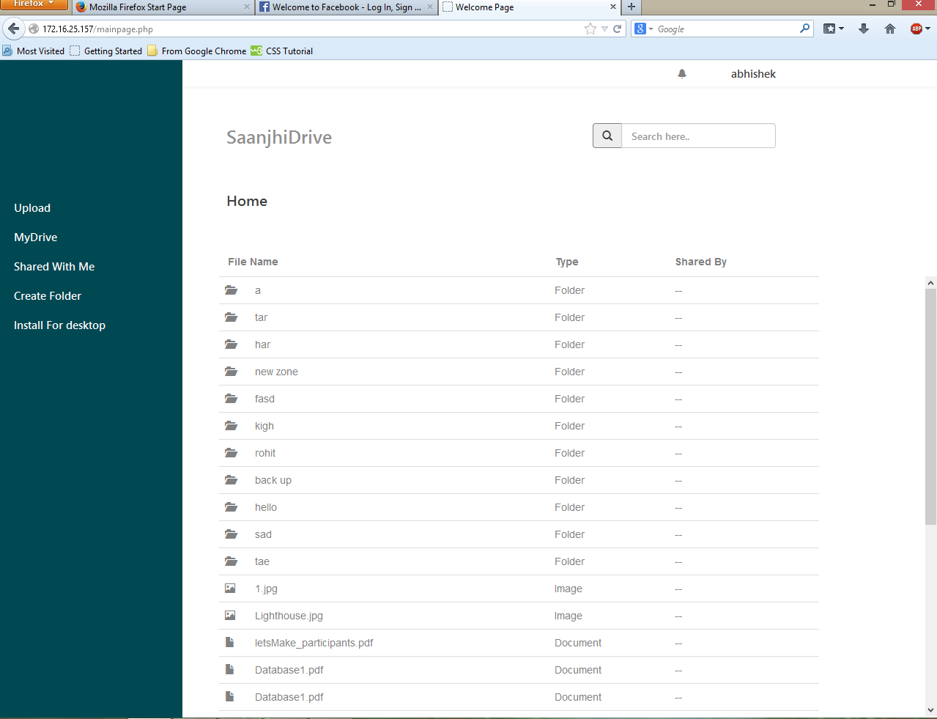

Then user will be provided Upload, My Drive, Sharedwithme, Create Folder and Install for Desktop.

When user keep mouse pointer on the username at top right corner, a window with home, logout, help options pop out.

When user presses install for Desktop then setup file will be downloaded.

**Search:**

User can also search files by name and in the text files user can search inside the text files.

For example welcome is present in the sandeep.txt it will show you like this

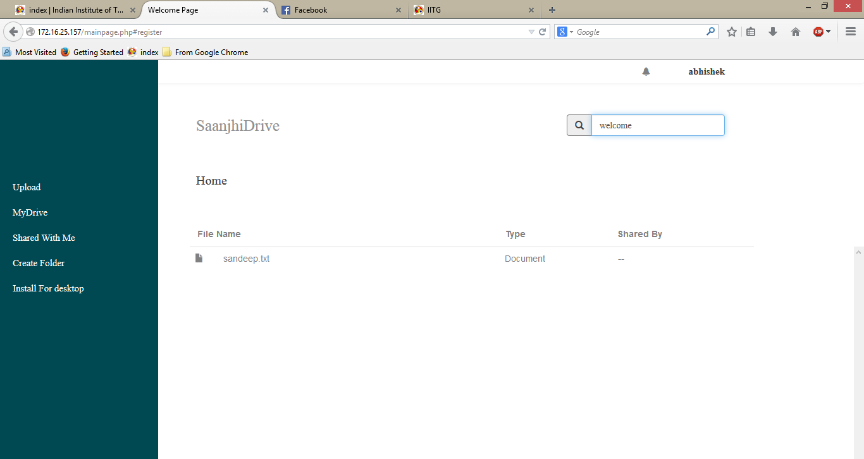

**Preview and Edit:**

User can preview the images and text files.

In the text files user can preview and edit it.

When user presses the Upload button then window will be pop up like this

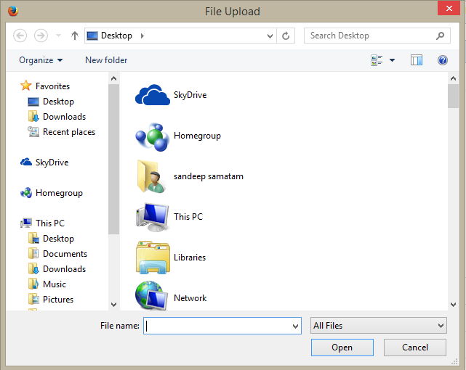

When user presses the create folder then one window will be pop up like this

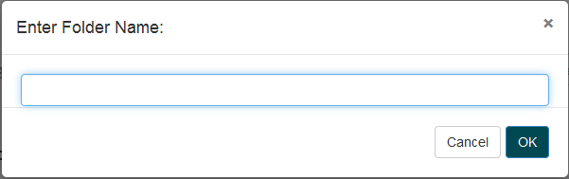

When user presses on the specific file then there will be options like Download, Share, Delete, rename and move like this

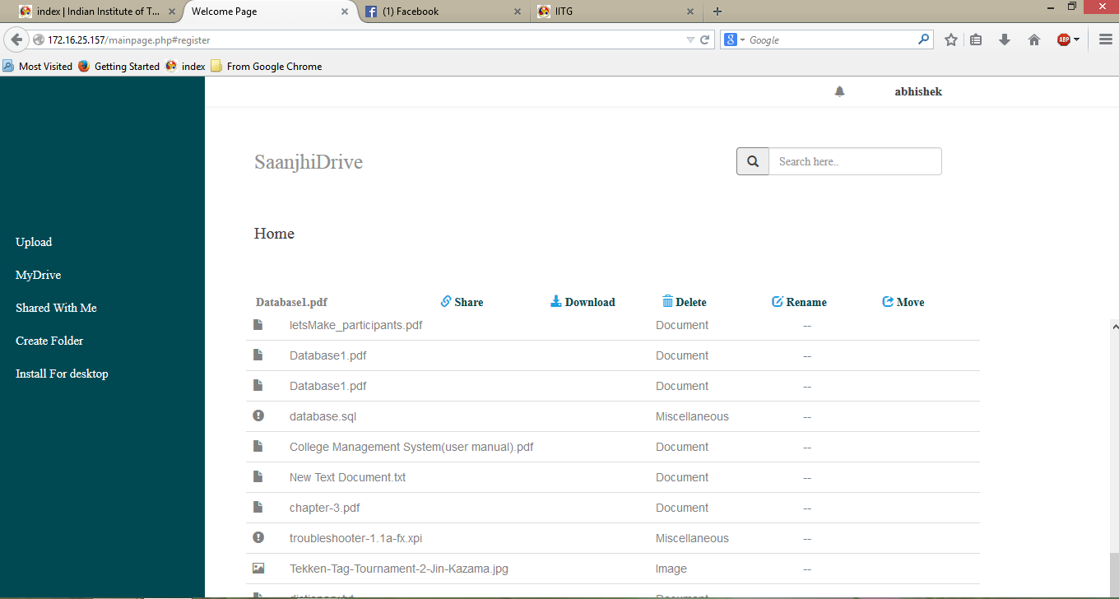

2. Desktop Application

**Framework:**

We have used Microsoft visual studio 2010 for the development of this application. We have used Visual C# windows Form Application for developing the GUI of this application. Visual C# is language which uses Microsoft .Net framework which can also use the code written in other languages.

**Purpose**

The main purpose of this app is to provide the offline access to the files or folders the users have stored on the server. All the files on the server will be visible in the specific folder allotted for the drive by this app. If some files are added to this folder they will be automatically synced to the online storage. This application serves the following essential functions:

* Login
* Upload
* Download
* Synchronizing

**Scope**

User can login via this application to the username/password given at the website. He can then add the paths of the file/folders that are to be added to his/her account on the file sharing server. He can sync the files and folders available on the online storage to the folder specified for the app.

If something is added to this folder, then by running the app we can upload these files to the storage.

**How to install**

**1.**  Download the set up from the website as follows: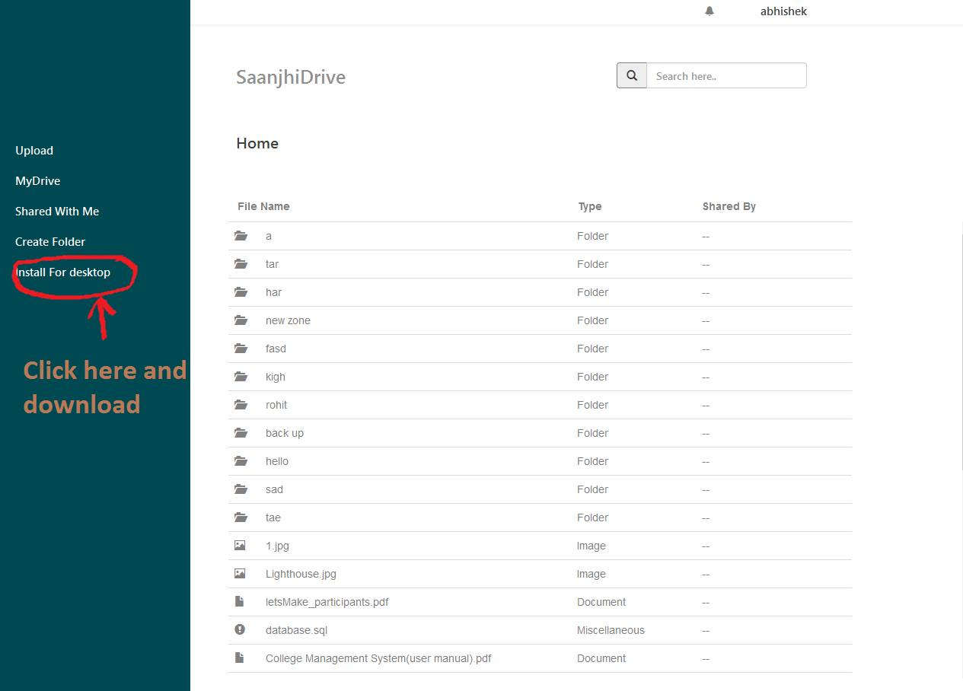

1. Double click the setup file and follow the installation instructions one by one as follows: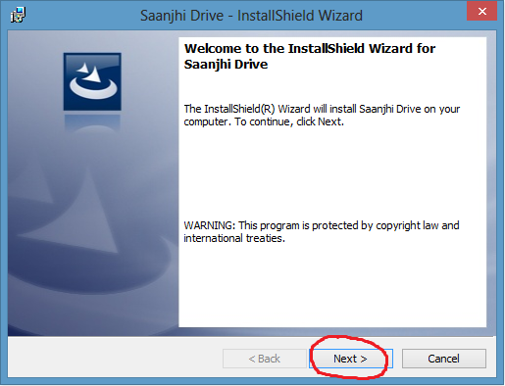 Select the installation folder and press next to continue: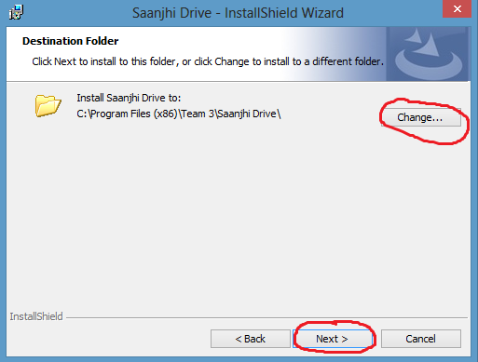
2. After the installation double click the icon on desktop and run the app.

**Using the app:**

1. Click on the settings and then click select folder to set the home folder to store files and folders from the server :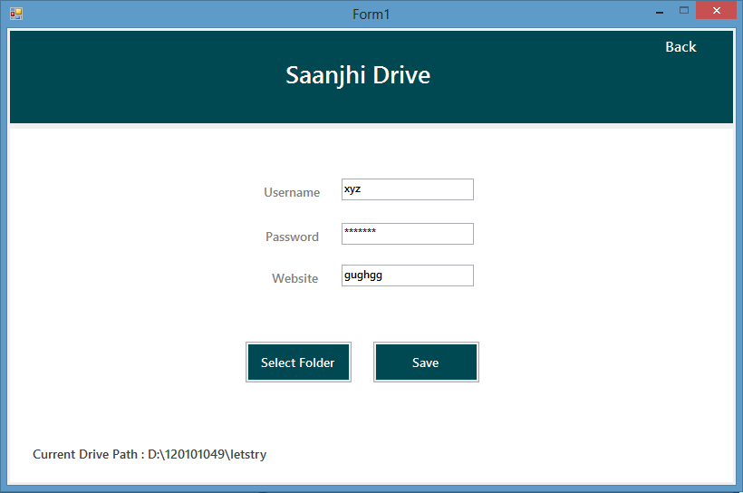
2. Fill the entries and click on the save button to save the settings in server :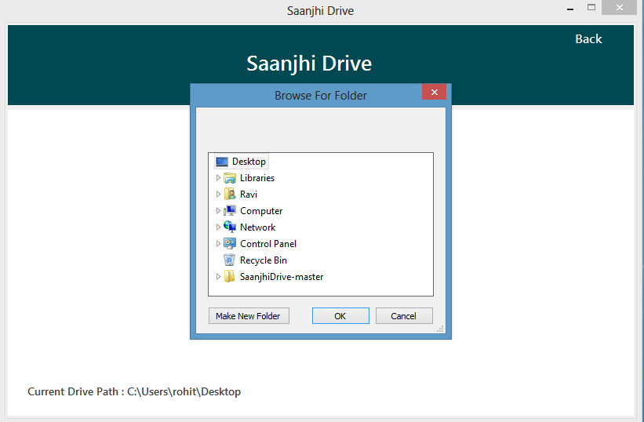
3. Click on the back button and then click on sync to sync the files with the online storage on server .